PRACTICAL QUESTIONS FOR DATA VISUALISATION AND ANALYTICS (CIA1C11)
Practical 9 – Predictive Analytics II (Regression)

Introduction: Assuming EDA and Data Preparation has been done for a dataset, and a fair amount of descriptive analytics has been generated. The next stage is to move into Predictive Analytics.

Predictive Analytics is an approach that uses statistical techniques to extract relationships from past data and use those relationships to (1) uncover hidden patterns and (2) make informed predictions about future outcomes. It has been blended with machine learning algorithms in recent years to improve the performance. Depending on the way these algorithms “learn” about the data, they can be categorized as supervised vs unsupervised learning.

In supervised learning, there is a target variable in mind to predict. The goal of supervised learning is to determine the “best” function such that when input variables are fed into the function, the model can predict the target variable well. One widely used algorithm of supervised learning is Linear Regression.

On the other hand, in unsupervised learning, there is no target variable in mind to predict. All variables are treated as input variables and what unsupervised learning does is to group data points by similarities/proximities together into a cluster. The goal is to model the hidden pattern or underlying structure behind each cluster. One widely used algorithm of unsupervised learning is k-Means Clustering.

Practical 8-9 will cover Predictive Analytics using the above two machine learning algorithms.

Objective: This aim of this practical is to introduce students to simple predictive analytics to present results of linear regression analysis.

Question 1 : To perform linear regression modelling
Question 2 : To analyze the results of regression using visualizations

Dataset: For our task this week, we will make use of a dataset containing a list of laptop prices for close to 1000 laptops with their specs such as CPU, GPU, RAM, screen size, weight, hard disk capacity and prices. For more details, you can visit this link (https://www.kaggle.com/ionaskel/laptop-prices). Take note that some modifications were made to the dataset.

Ready? Let’s get started!

Question 1 (Importing KNIME workflow, writing output to file)

The purpose of this question is to learn to:
- Partition the data into training set and testing set
- Train the regression model using the training set
- Validate the regression model using the testing set

In the process of exploring the data, we may be able to discover things such as:
- Which are the important features (key predictor) that determines a laptop’s price?
- Is there agreement between the performance of regression models for the training and testing partition?

- Import KNIME Workflow
Download the workflow P09_Starter.knwf from TP-LMS. Launch KNIME. Select File > Import KNIME Workflow.

Double-click on the workflow in the explorer pane to bring up the workflow in the main canvas.
Your workflow should resemble the one shown below.

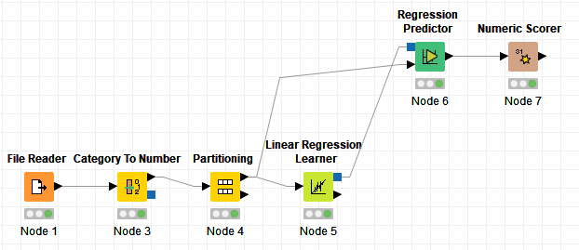

If File Reader node has a warning sign, you need to make sure that File Reader node points to the correct location of the Input file ((Right-click configure Browse browse to correct location select Laptop Prices.csv)

Linear regression attempts to model the relationship between two variables by fitting a linear equation to observed data. One variable is the dependent (target) variable while one or more variable(s) is/are considered to be the explanatory (input) variable(s). For example, a modeler might want to relate the weights of individuals to their heights using a linear regression model.

Before attempting to fit a linear model to observed data, a modeler should first determine whether or not there is a relationship between the variables of interest. This does not necessarily imply that one variable causes the other (for example, higher SAT scores do not cause higher college grades), but that there is some significant association between the two variables.

A linear regression line has an equation of the form Y = a + bX, where X is the explanatory variable and Y is the dependent variable. The slope of the line is b, and a is the intercept (the value of y when x = 0).

- Convert Category Fields to Numeric Fields
Double click on the Category to Number node to bring out its configuration window.

Since linear regression only works on numeric fields. For our exercise, we will use the Category to Number node to convert two fields (Cpu and Gpu type) into numbers.
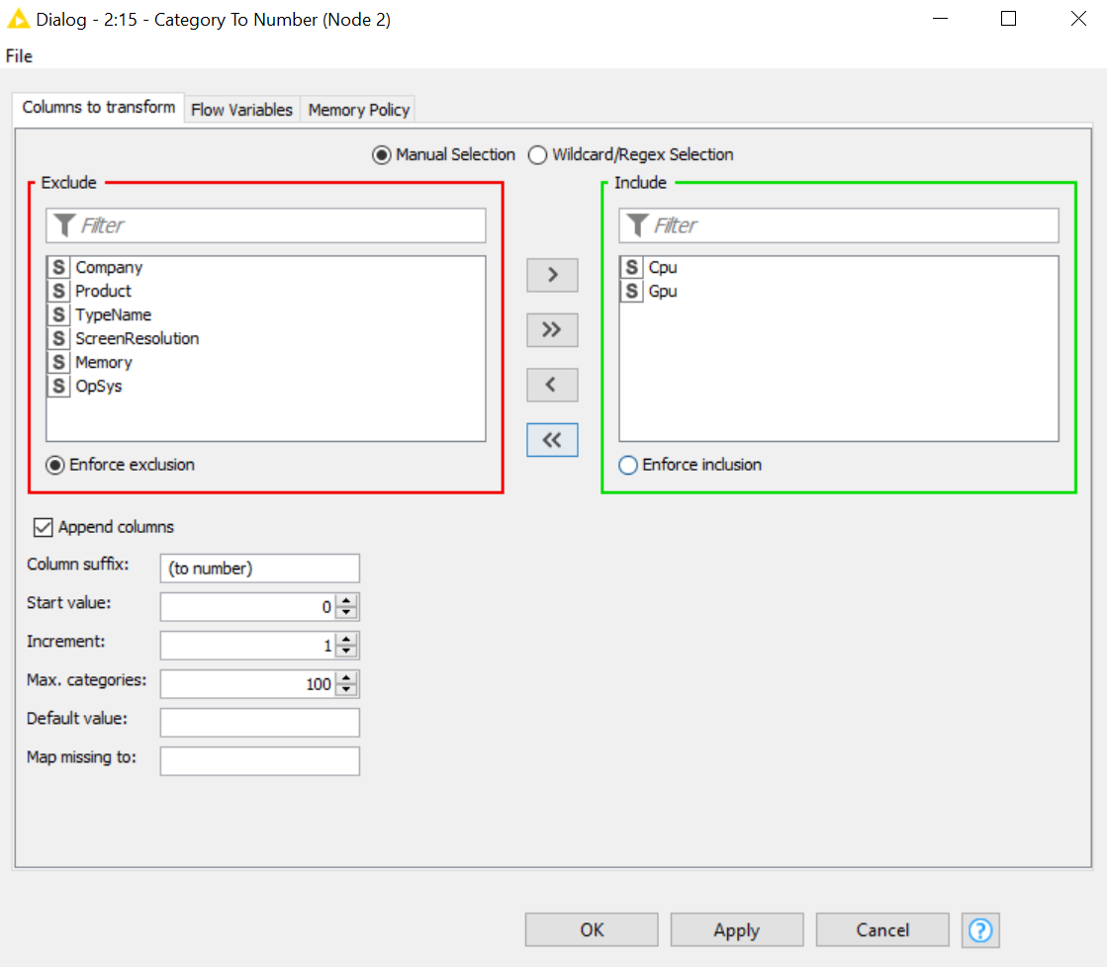

Execute the Category to Number node and look at the output. (Processed Data)

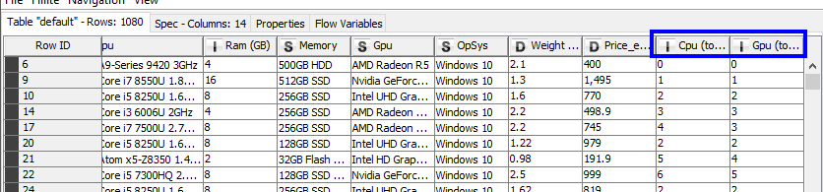
 | Discussion: What assumptions are we making when we convert categorical data (like CPU) to numbers?
Answer:

We are assuming that the difference between each CPU chip is equivalent and comparable.

Say we convert ‘Apple’, ‘Banana’ and ‘Coconut’ into 1, 2 and 3.
We know the difference between 1 and 2, and the difference between 2 and 3 is equivalent.

However, can we be equally sure that the difference between Apple and Banana and the difference between Banana and Coconut are equivalent?

Converting categorical data into numbers for purpose of regressions assumes such equivalence.

- Partition the Data into Training Set and Testing Set
Double click on the Partitioning node.

Look at the configuration of the Partitioning node. We partition our dataset into 70% - 30%. The plan is to use the 70% subset as the “training” dataset, this subset would be used to generate the regression model.
The 30% subset would be used as the “testing” dataset, this subset would act as a previously unseen dataset which would provide an unbiased assessment of the regression model.
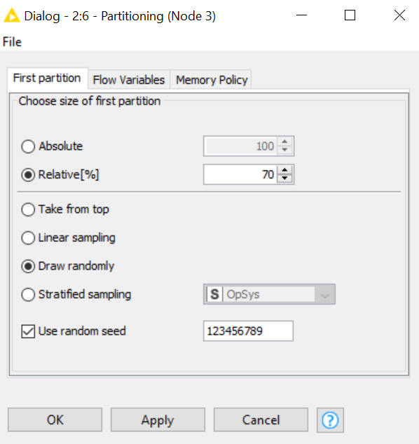
The node is configured to use a random seed (in this case 123456789) such that the sampling can be replicated.

X`

- Train the Linear Regression Model
Take a look at the configuration for the Linear Regression Learner node
We are setting Price_euros as the target (dependent variables).

For the inputs (independent variables), we are using Inches, Ram (GB), Weight (Kg), Cpu (to number) and Gpu (to number).

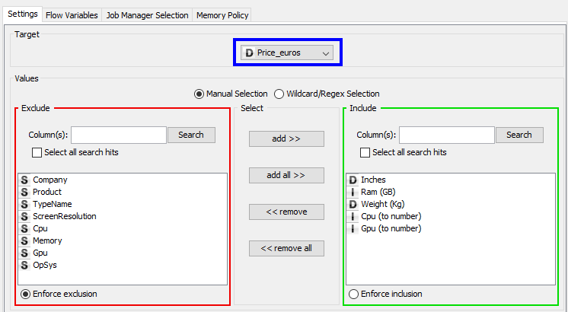

Go ahead and execute the Linear Regression Learner node.
Right-click on the node and select Coefficients and Statistics
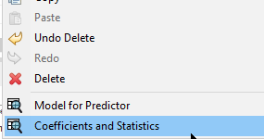

Note: There might be slight difference in the values you see and the one shown in the screenshot below.
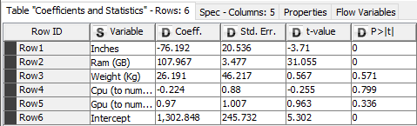

 | Question:  - Which are the important features (key predictor) that determines a laptop’s price?
To answer this question, we look at the right-most column in the coefficients and statistics output.

The value of P (often referred to as P-value) would give us an indication of the predictive importance of the independent variables (inputs).

A predictor that has a low p-value (< 0.05) is likely to be a meaningful addition to your regression model because changes in the predictor's value are related to changes in the target variable

Answer:

- Tune the Linear Regression Model and Re-Assess the Training Set
Earlier on in point 4, we found that a predictor that has a low p-value (< 0.05) is likely to be a meaningful addition to our regression model. For our case, screen size (Inches) and RAM (Ram (GB)) are deemed to be important predictor for laptop prices.

Let’s re-configure the Linear Regression Learner node. Use only Inches and Ram (GB) as the inputs (independent variables).
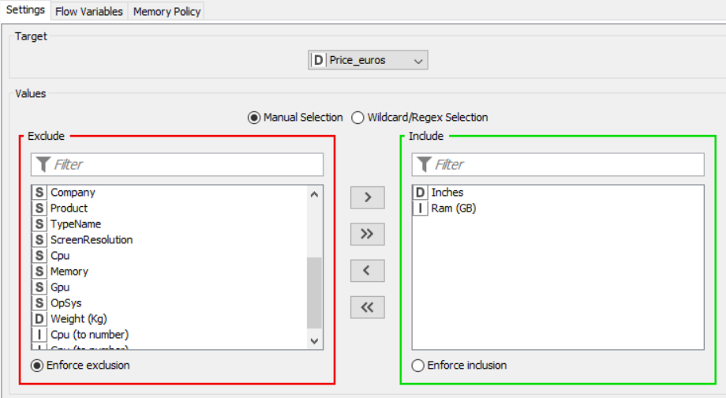

Execute the entire branch of nodes in your workflow.

Open the output of the Linear Regression Learner node (right-click Coefficients and Statistics).

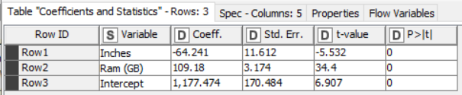
 | Discussion: What do you notice about the new linear regression model?
Answer:

There are only 2 inputs (independent variables).
The p-values are both < 0.05, which means both inputs (Ram and Inches) are important predictors for the target value (lap prices) .

- Predict Using the Linear Regression Model on the Training Set
Next, we will move on to the Regression Predictor node. This node allows you to make use of the regression model produced by the Linear Regression Learner node and carry out prediction based on input data.

Execute the Regression Predictor node and look at the output. (Right-click on node, select Predicted data). The two columns of interest to us are:
- Price_euros – this is the actual price of the laptop, it was in the original dataset)
- Prediction (Price_euros) – this is the predicted price based on your regression model
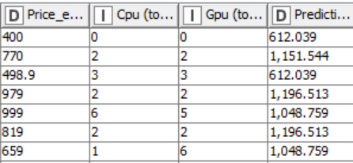

You can see that there are some predictions that are quite close to the actual, but some there are way off target. However, rather than eyeball each pair of actual price vs. predicted price, there is a better way for us to assess the quality of our regression model.

- Assess the Model with Training Set
The Numeric Scorer node is the node used to provide a summary of the quality of the regression model. In the configuration, you will select the Reference column (in our context, it is the actual laptop price Price_euros) and the Predicted column (in our context, it is the predicted laptop price Prediction (Price_euros))
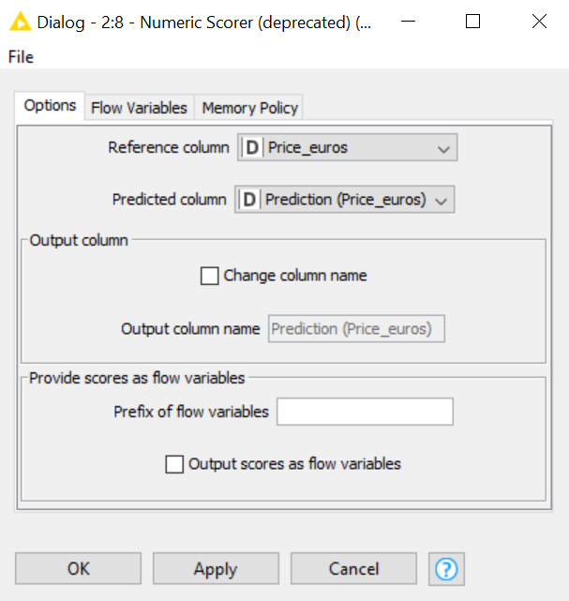
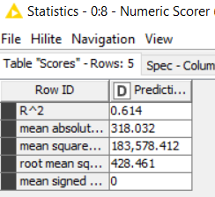

R^2 (R-squared) is a statistical measure of how close the data are to the fitted regression line. It is also known as the coefficient of determination. It is sometimes expressed as a percentage. R^2 value ranges from 0% to 100% (or 0.0 to 1.0 as in the case in KNIME)

0% indicates that the model explains none of the variability of the response data around its mean.
100% indicates that the model explains all the variability of the response data around its mean.

Along with R^2 are four measures of error. Naturally, errors should be as small as possible.

 | Discussion: A regression model that can produce good prediction should have….
Answer:
High / Low R^2
High / Low mean absolute error
High / Low mean square error
High / Low root mean squared error
High / Low mean signed error

- Predict Using the Linear Regression Model + Assess the Testing Set
We now want to check the regression model’s performance against the “testing” dataset.

Add a Regression Predictor node into your workflow. Connect the top output port from the Linear Regression Learner node to the top input port of this newly added Regression Predictor

Connect the bottom output port of the Partitioning node to the bottom input port of the newly added Regression Predictor node. This will feed the ‘testing’ dataset to the Regression Predictor node.

Add a Numeric Scorer node downstream from the Regression Predictor node. Configure it to use Price_euros as the Reference column and Prediction (Price_euros) as the Predicted column.

Execute this new branch of nodes in your workflow.
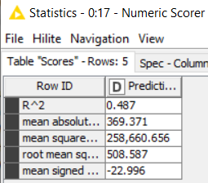

 | Question:  - Is there agreement between the performance of regression models for the training and testing partition?
Answer:

- Predict Using the Linear Regression Model for the Entire Dataset (for visualization purpose later)
Add a new Regression Predictor node (your third one) to your workflow. Repeat the process of connecting the output model from the Linear Regression Learner node to this newly added Regression Predictor node.

Feed the pre-partitioned data from the Category To Number node into the third Regression Predictor node. Execute the Regression Predictor and examine the output, verify that you have 1080 rows.

Your workflow should resemble the one shown below.
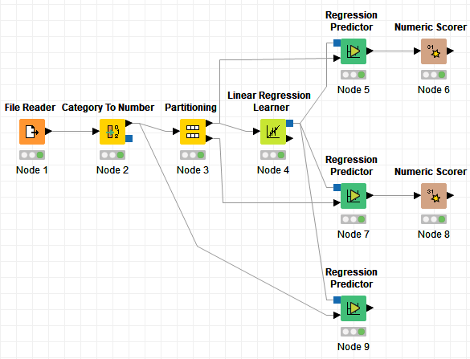

- Write to CSV File
Add a CSV Writer node downstream from third Regression Predictor node. Name the file as = Laptop_output.csv. Configure the node to include the Row ID and Column header. If file exists, overwrite it. Execute the CSV Writer node and verify that the file is created in the destination that you have set.

- Note Down the Coefficients and Intercept

Lastly, before we exit KNIME, note down the values of the coefficient and intercept in step 7. We need it for the next question Power BI.

 | Question:  - Write down the linear regression equation of this model.
Answer:

- Re-cap KNIME Workflow for Linear Regression
To learn from the inputs and target of the training set.

To split the dataset into 2 partitions : training set and testing set.
Then produce a linear regression model. You can write down the regression equation using “coefficients”.
Target must be numeric. Inputs can be categorical or numeric.
Training set is for training the regression model.
Data set has one target variable and various inputs / features/predictors.
Testing set is an “unseen” set of data to check model performance.
p-values < 0.05 are important inputs. Tune the model by retaining only the important inputs.
Linear regression model can only take in numeric inputs. Hence the need to convert categorical fields to numeric fields.


Training Set : Compares predicted with actual target. Measures the prediction errors.
Training Set : Use the model produced in Learner node to predict target value for each row of data.

Full Set : For visualisation purposes in Power BI later.

Ask :
- Are predicted and actual target aligned perfectly?
- Are the residuals close to zero?
- Can you create a dashboard to predict laptop prices?
Model Assessment : If drastic change in prediction errors occurs between Training & Testing sets, then overfitting has occurred. So model needs to be adjusted.
Testing Set : Compares the predicted with actual target. Measures the prediction errors.

Testing Set : Use the model produced in Learner node to predict target value for each row of data.

Question 2 (Visualizing the data )
We will now read the CSV file prepared in Question 1 into Power BI desktop. This will allow us to analyse the result from the regression model using
- scatter plot – to compare the actual prices vs the predicted prices
- scatter plot – to analyse the residual plot
- table, card, slide, filters – to create a visualization to predict the prices of laptops.

For Mac Users : Use Power BI Service

Option 1 : Use Power BI Service
Power BI Service cannot create new column for “Residuals”. To get around this : Open .csv file Add new column called “Residuals” in Column Q Let Residuals = Price_euros – Prediction(Price_euros) Set Q2 = M2 * P2 then copy formula down the column Save file

The column Price_euros has a mixture of integer and decimals. But Power BI Service does not read in as a numeric data type. To get around this : Open .csv file Highlight the numeric values in the column for Price_euros increase to 1 decimal place Save file

Sign in to Power BI Service (in the cloud) Click Get Data Click Get Under File Select Local File Navigate to Laptop_output.csv and select file. You should see the dataset Laptop_output.csv in Power BI Service. Click ⁞ next to Laptop_output.csv Select Create Report. A blank canvas will appear in Report View. You can then continue to step 2.

Note : You will not be able to create New Parameter and New Measure in Power BI Service. As such, please skip steps 2.5 to 2.10.

Option 2 : Power BI Desktop that is accessible via TP WVD
Alternatively, login to TP Window Virtual Desktop using your TP student email account. Then click on DAVA Desktop to access Power BI Desktop. You can do the entire Question 2 there.

- Create New Column for Residuals
Launch Power BI desktop and read the CSV file produced in Question 1 into it. Go to Data view.

We start by creating a new column called Residual. In regression tasks, the difference between the observed value of the dependent variable (y) and the predicted value (ŷ) is called the residual. Having residual values that are close to 0 indicates accurate prediction by the regression model.

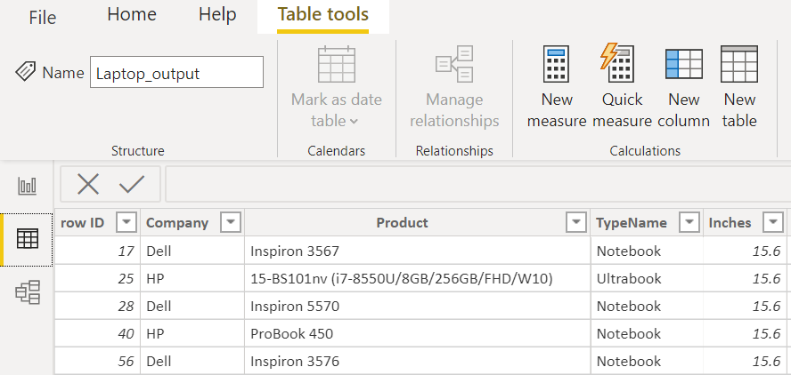
Click on Table tools New Column

Enter the expression:
Residuals = Laptop_output[Price_euros] - Laptop_output[Prediction (Price_euros)]
Press Enter.
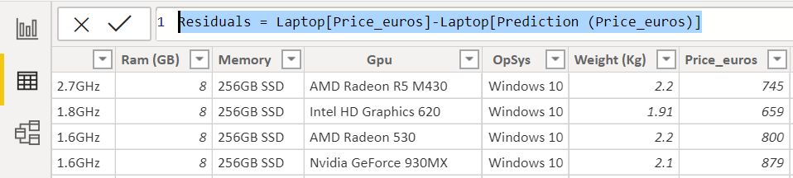

You should see a new column for the residuals in the right-most column.

Go to Report view. We will create 2 separate scatter charts.
- The first scatterplot – Predicted vs Actual Laptop Price.
- Details: Row ID
- X-axis: Prediction (Price_euros)
- Y-axis: Price_euros
Go to the Format palette (click on the paint brush icon), turn fill point to “off”.
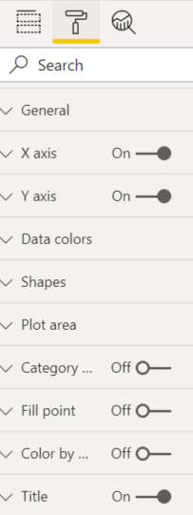
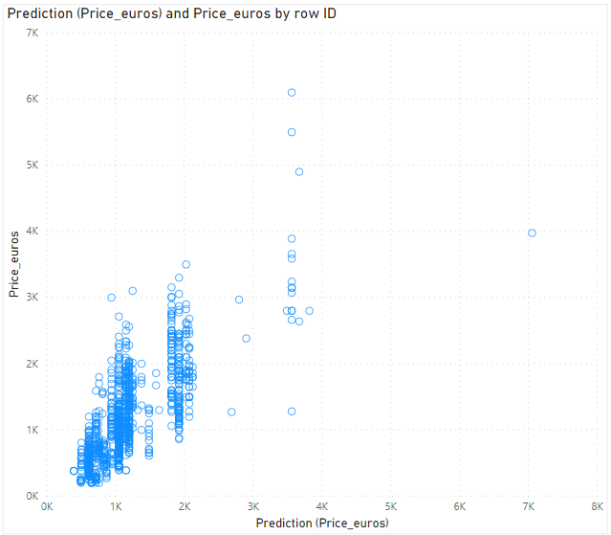

 | Discussion: How should the Predicted vs Actual graph for the perfect regression model (100% accuracy model) looked like?
Answer:

A perfect model would predict the price with 100% accuracy, this means, a laptop that costs $1000 euros would be predicted to cost $1000, one that costs $2000 would be predicted to cost $2000.

A plot for the perfect model would have all the points forming a perfect diagonal line in your graph.

- The second scatterplot – Residual Plot
- Details: Row ID
- X-axis: Prediction (Price_euros)
- Y-axis: Residuals
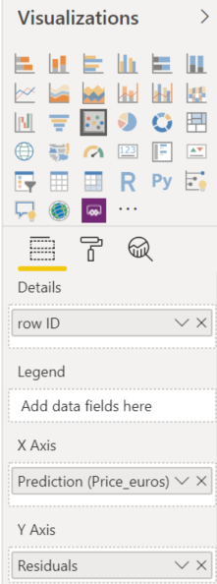
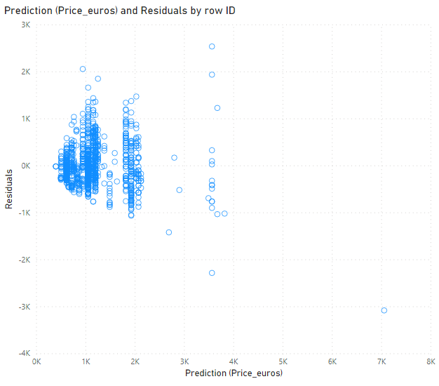
Go to the Format palette (click on the paint brush icon), turn fill point to “off”.

 | Discussion: How should the residuals plot for the perfect regression model (100% accuracy model) looked like?
Answer:

A perfect model would predict the price with 100% accuracy, this means, residuals would be 0 for all laptop models.

A residual plot for the perfect model would have all the points forming a perfect horizontal line on 0 on the Y-axis.

- Add Filters
Click on the ‘+’ sign to add a new page to your report.

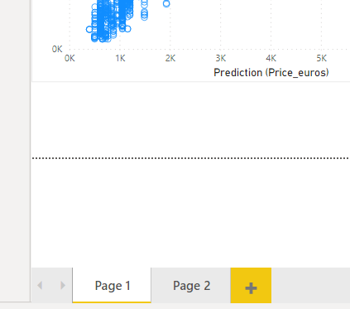

In the new sheet, add two filters to “Filters on this page”.
For the first filter, drag and drop Cpu to the Add data fields here area.
For the second filter, drag and drop Gpu to the Add data fields here area.

- Create Sliders
In the Modeling tab, select New Parameter
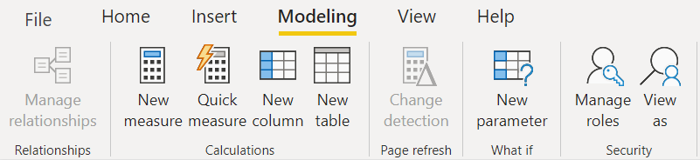

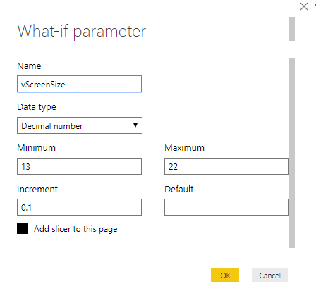
Enter the following
Name: vScreenSize
Data type: Decimal number
Minimum: 13
Maximum: 22
Increment: 0.1

Ensure that the checkbox for “Add slicer to this page” is checked (shaded)

Click OK.

Go to the Format palette (click on the paint brush icon) and do the following :
- Under border, turn on the border.
- Under Slider header, change the text size to 18.
- Under Numeric Inputs, change the text size to 16.

- Repeat the steps in step 5 and create one more parameters with the following settings

Name: vRAM
Data type: Whole number
Minimum: 2
Maximum: 64
Increment: 2
Add slicer to this page: Checked

Go to the Format palette (click on the paint brush icon) and do the following :
- Under border, turn on the border.
- Under Slider header, change the text size to 18.
- Under Numeric Inputs, change the text size to 16.

- Create New Measure
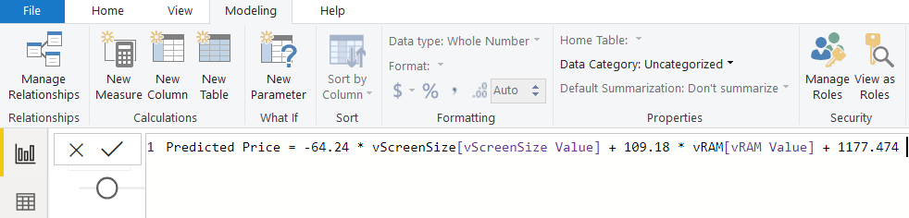
Still in the Modeling tab, add a new Measure.
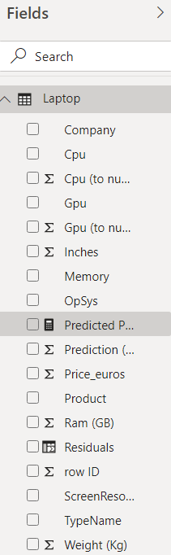
We will call this measure Predicted Price.
Predicted Price = -64.24 * vScreenSize[vScreenSize Value]
+ 109.18 * vRAM[vRAM Value]
+ 1177.474

The numbers (-64.2, +109.18, 1177.4747) are based on the Linear Regression coefficients in KNIME.

Enter the formula into the formula bar and press enter.

A new measure called Predicted Price will appear in the Fields panel.

Note :
In the Modelling tab, a new measure differs from a new column.
A new measure is evaluated when you use it in a visual, but a new column is calculated for each row of the data and forms part of the data table.

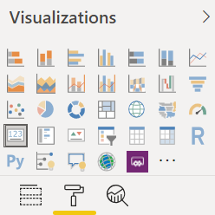
- Card Viz
Add a Card visualization to the report.
Select the measure Predicted Price as the field.

Go to the Format palette and do the following :
- Under Data Label, select None for Display units.
- Under Border, turn on the border.
- Under Category Label, change the text size to 16.
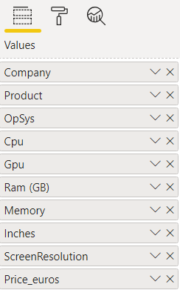
- Table Viz
Finally add a Table viz and select the following:
- Company
- Product
- OpSys
- Cpu
- Gpu
- Ram (GB)
- Memory
- Inches
- ScreenResolution
- Price_euros

- Use this report to predict price of laptop
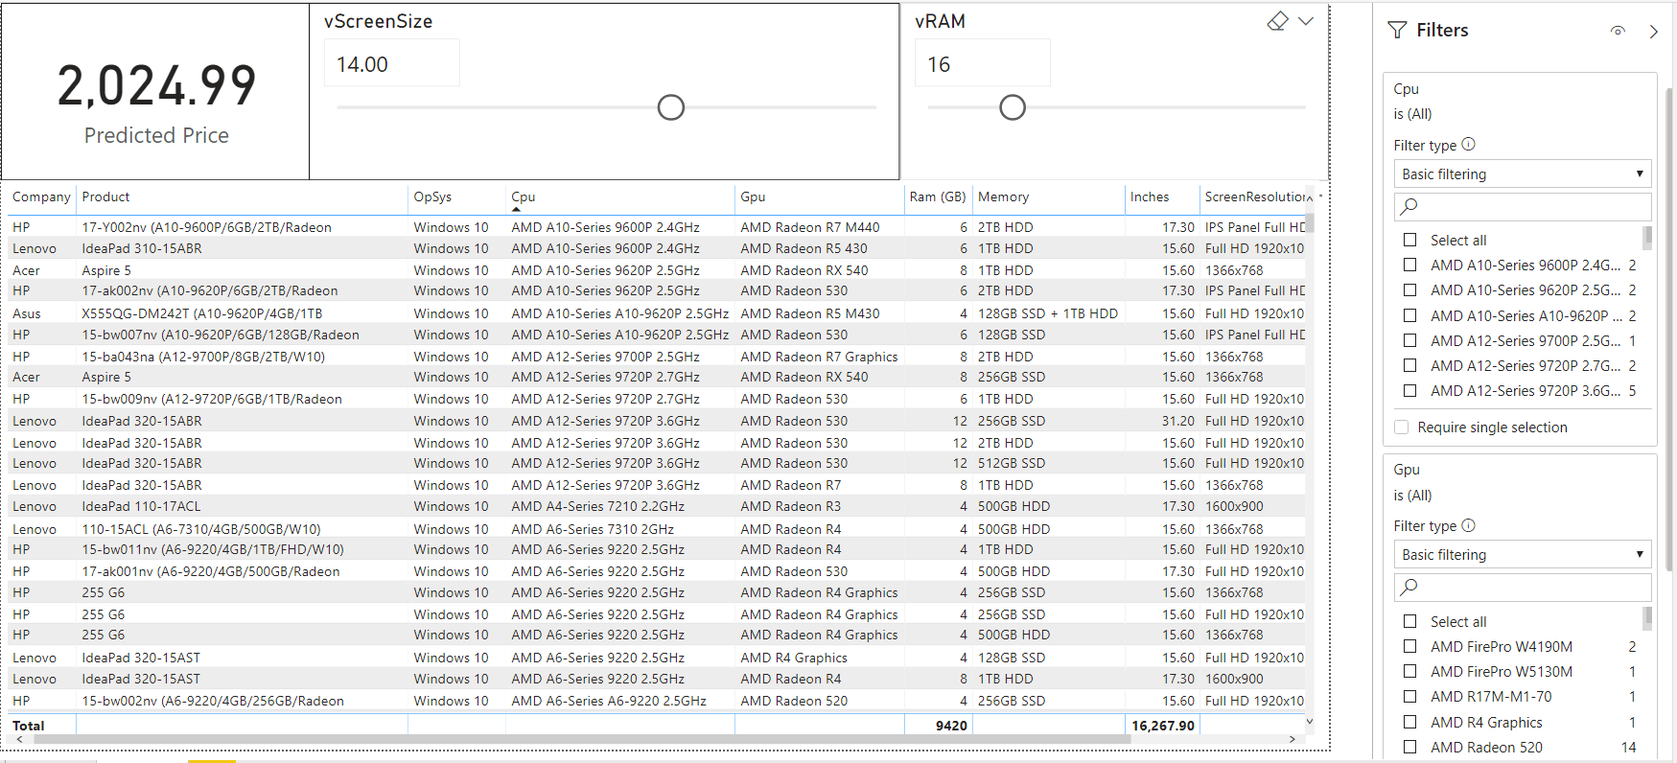
You report sheet should resemble the one shown below.
You can try selecting the CPU, GPU from your Filters, and use the Sliders to select the screen size and RAM, the card will make use of the regression equation you have derived in Question 1 to compute the predicted laptop price matching the specs you have entered via the Slicers and Sliders.
Question 3 (Will not be discussed in class)
- We will verify the expression in Question 2.

Add the Prediction (Price_euros) field into your Table viz in Question 2.
Pick one row from your input file, make your adjustments to the Slicers and Sliders to match the values of the various fields / parameters of your selected laptop.

Look at the predicted value displayed in the Card viz and compare it to the predicted value in your Table viz.

If it is close enough, it means you did not make any mistakes entering the expression for the Predicted Price measure.

- End of Practical 9 -
 | Summary:
In this practical, we looked at how we can prepare data for, and, carry out linear regression. We explored how we can determine the accuracy of our regression model and how we can make use of the regression formula to make predictions.

In this practical we made use of the following new nodes (not covered in previous practical) in KNIME.
Node |  | Purpose | Remarks
Category To Number |  | This node takes columns with nominal data and maps every category to an integer.
Partitioning |  | Divides the input dataset into two partitions, typically, train and test data. | Training partition is what regression model will use to carry out learning  Testing partition provides a truer test of the model’s performance.
Linear Regression Learner |  | Use the input data to carry out regression for the defined target variable. | Check out Wikipedia on how linear regression works https://en.wikipedia.org/wiki/Linear_regression
Regression Predictor |  | Used the regression model produced by the Linear Regression Learner node to carry out the prediction using input data
Numeric Scorer |  | Provides a numeric indication on the performance of regression model

